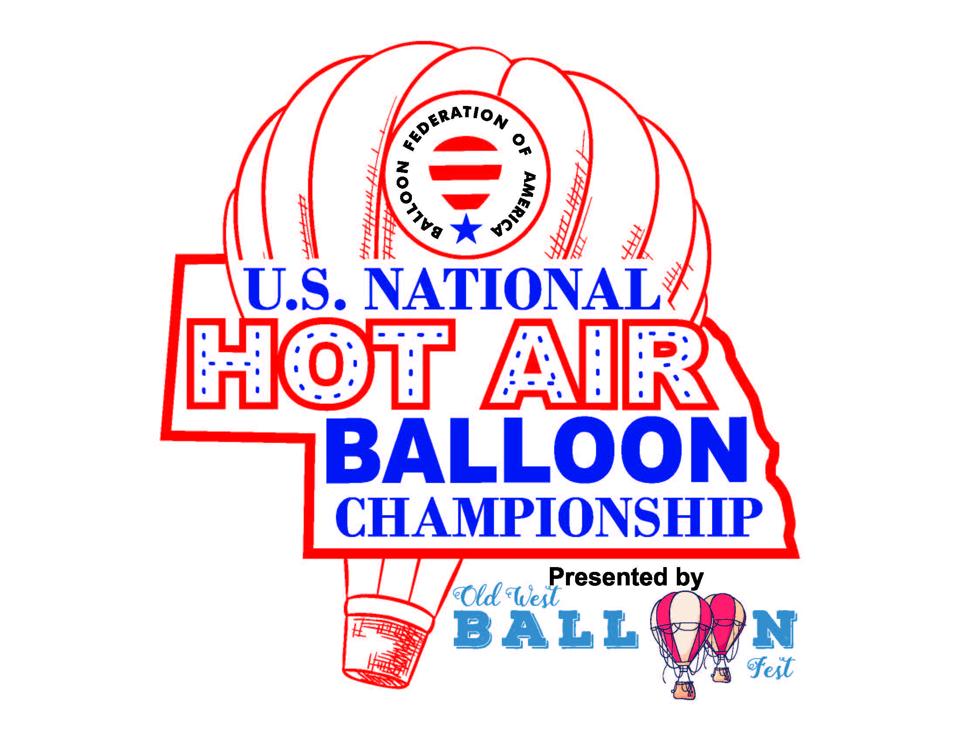

PRESS RELEASE – FOR IMMEDIATE RELEASE – July 7, 2020

Contact: Colleen Johnson – Executive Director, Old West Balloon Fest

**Due to the recent Covid19 cases spiking around the Nation, Balloon Federation of America has announced that the National Championships this year will be postponed to 2021. A National qualifying event will take place instead of the Championship. The national qualifying event and Old West Balloon Fest will still take place as planned August 12-15.**

The organizers of Old West Balloon Fest and Balloon Federation of America have worked closely to determine if a National Championship makes sense for 2020. Our decision was made based on two major factors. The first factor is that we have 30% of nationals’ pilots in the at-risk age group, and second, the concern of some nationals’ pilots who were worried about traveling through 3-4 states that have Covid19 cases spiking in order to get to Nebraska. Many of those pilots have already made the decision to not participate this year. We would regret holding a Nationals Competition that did not represent the best 50 pilots in the nation. This was a tough decision and one that was not made lightly, but it is what is best with the current circumstances. Scotts Bluff County will host the 2021 AND 2022 US Nationals Hot Air Balloon Championships.

The good news is that Old West Balloon Fest will be running tasks for qualification for next year’s nationals in Scotts Bluff County. What does that mean for this year’s event? We will have a four-day competition for pilots to qualify for 2021 Nationals championship held in Scotts Bluff County. There will be a total of approximately 20 competition balloons and 15-20 Old West Balloon Fest pilots joining them August 14th and 15th. The WNCC night glow will feature 15-20 balloons on August 12th. We expect 35-40 balloons for the KNEB night glow located at the Grasslands at Five Rocks featuring both competition balloons and Old West Balloon Fest favorites. We will keep the public informed of all Panhandle Public Health Department requirements to attend the event through our website and Facebook pages.

For more information about the event (volunteer and vendor sign up), please visit our website theoldwestballoonfest.com.

If you have questions, please contact Colleen Johnson, Executive Director Old West Balloon Fest

[Colleenjohnson302@gmail.com](mailto:Colleenjohnson302@gmail.com) or (308)225-0128